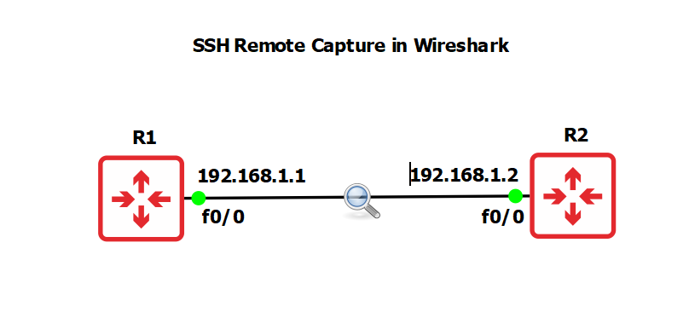

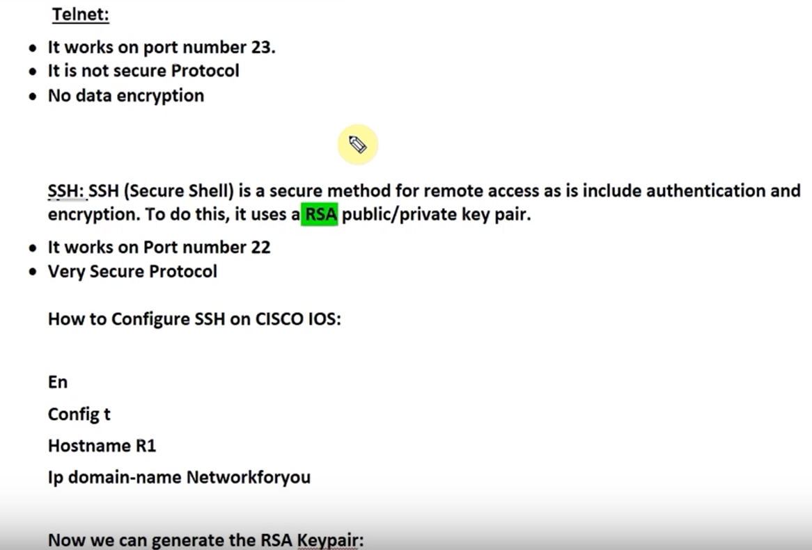

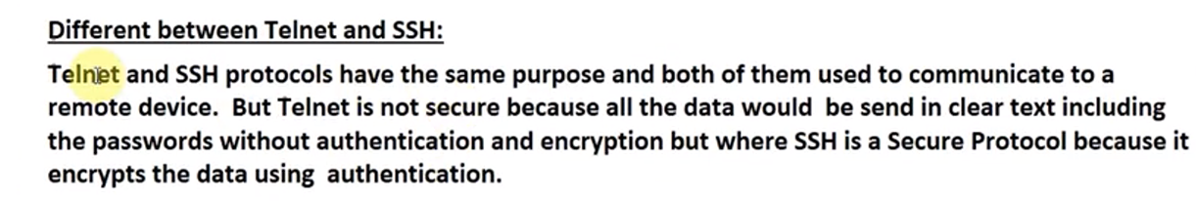

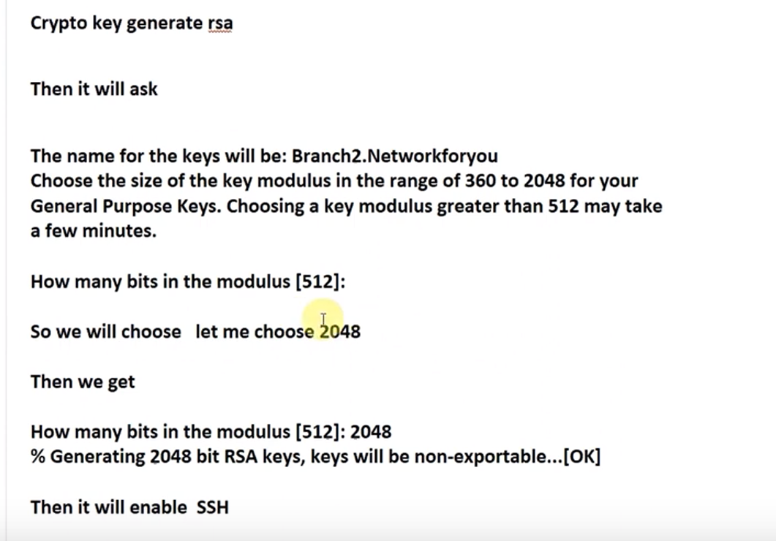

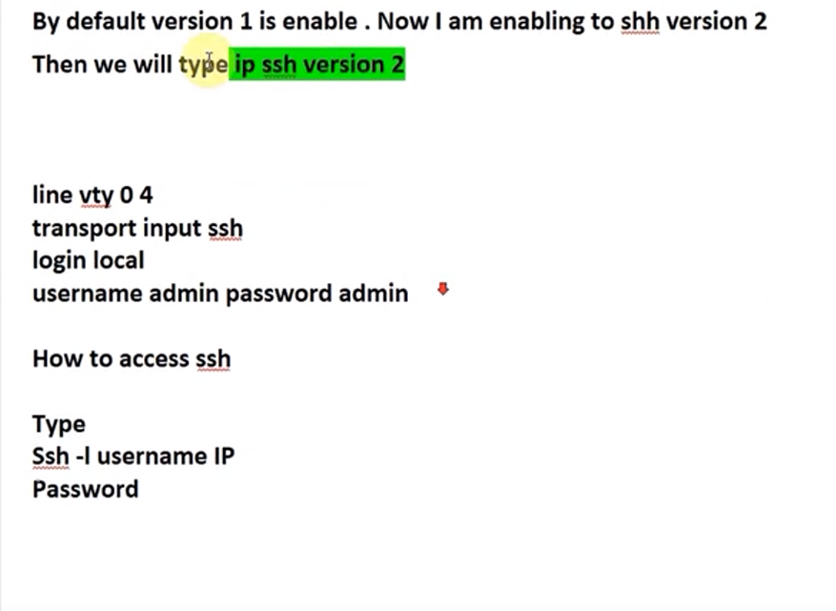

1. Change router symbols, right click 🡪 symbol selection -> affinity-square-red 🡪 router (optional step)

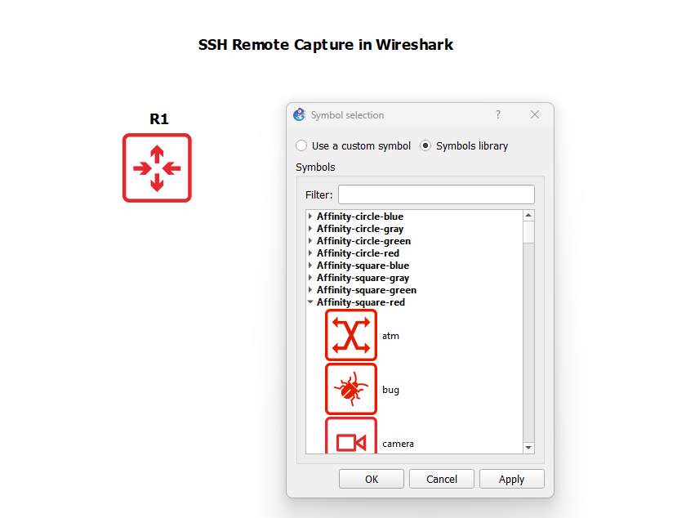

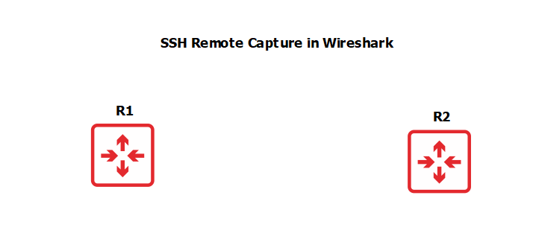

1. Turn on Auto-Idle PC for both routers

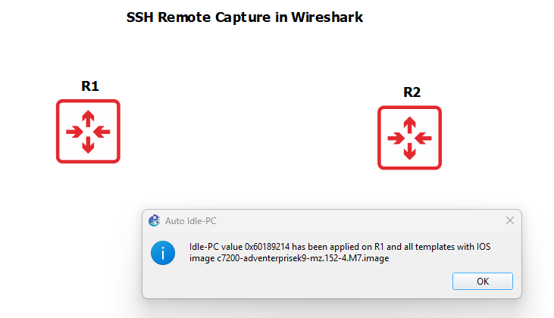

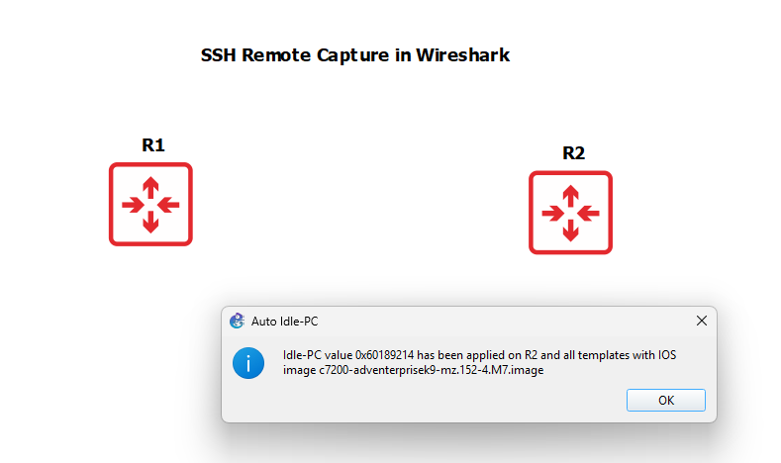

1. Configure the following commands for router 1 and 2. The command enable password cisco is used on Cisco devices (like routers and switches) to set a password for privileged EXEC mode (also called enable mode). Only users who know the password can enter enable mode by typing the enable command from user EXEC mode.

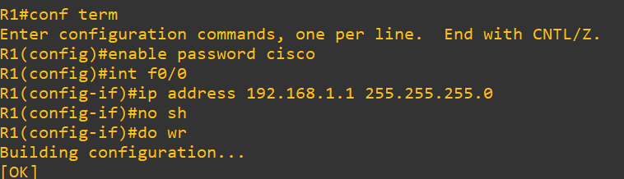

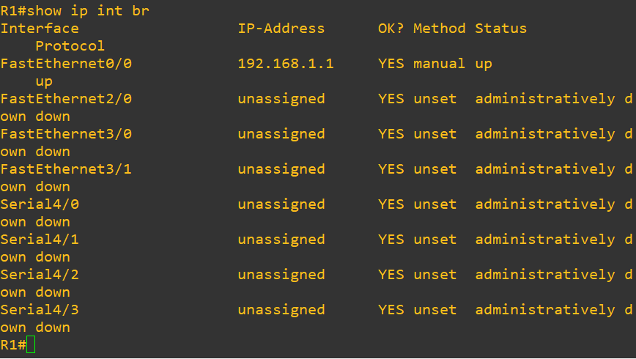

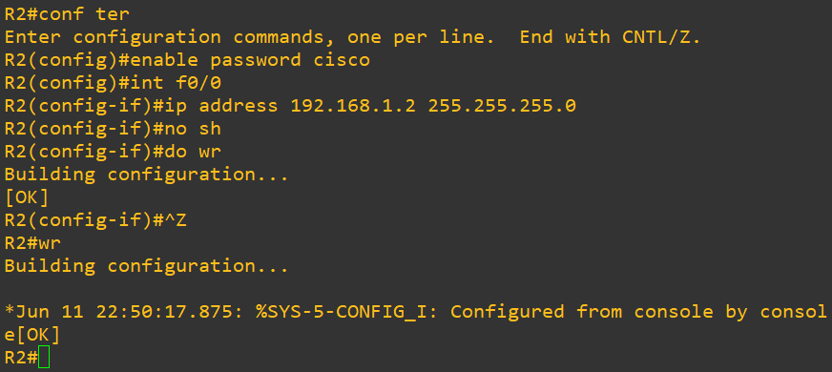

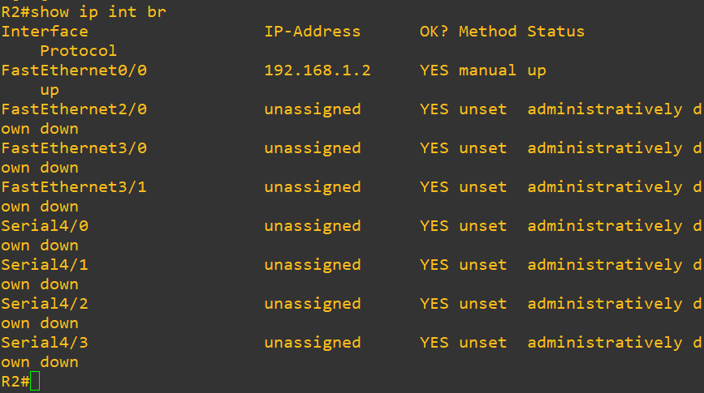

1. Capture packets on direct link using Wireshark before configuring ssh on R2

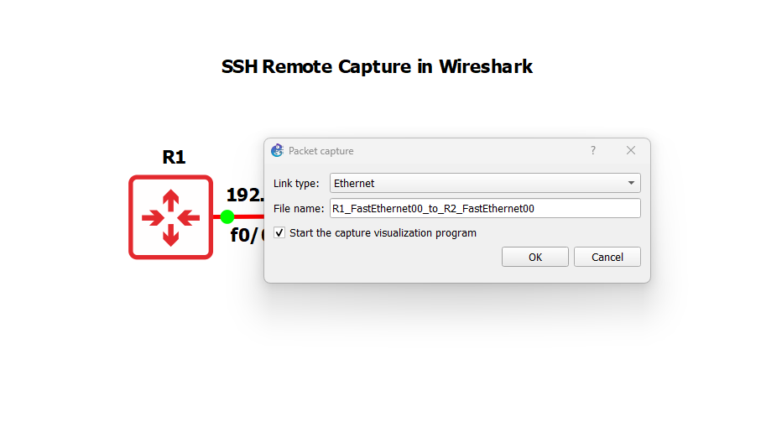

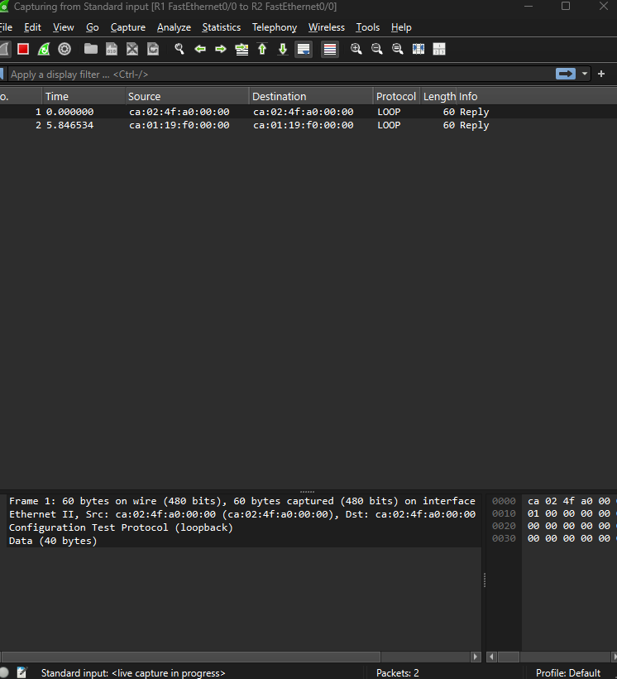

1. Ip ? will tell the options available to be added with ip command. We’ll use domain-name to set up domain for ssh. Setting up a domain namefor SSH on a Cisco device (such as a router or switch) is a required step for generating the RSA key pair used for secure SSH communication. This command requires a hostname and domain name to generate a fully qualified domain name (FQDN), which is used to create a unique key pair.

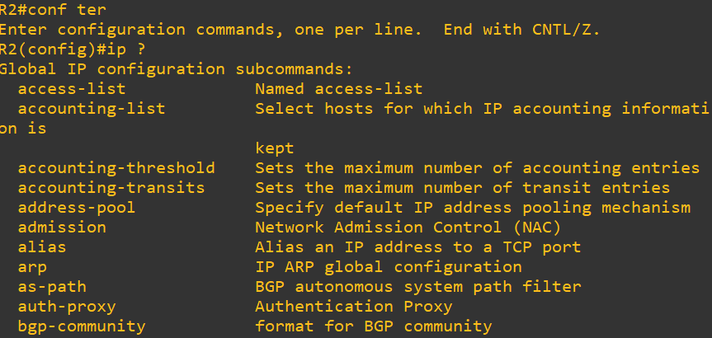

1. CDP packets exchanged between routers in which they tell different information about each other like their model number, version number, 7. IP etc. Wireshark will capture this  
   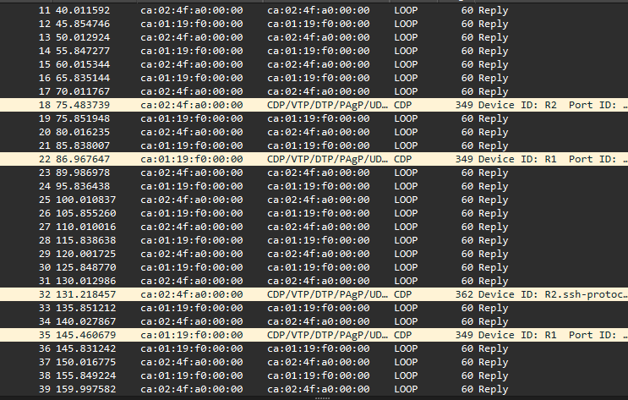
2. Generate rsa keys for encrypting packets. If take less than 760 bits as key size then will not support SSH version 2

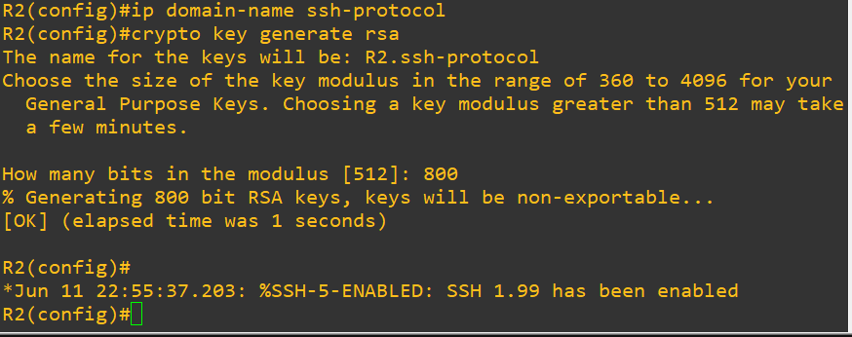

1. With transport input can set the protocol to use, we can even ste both telnet and ssh

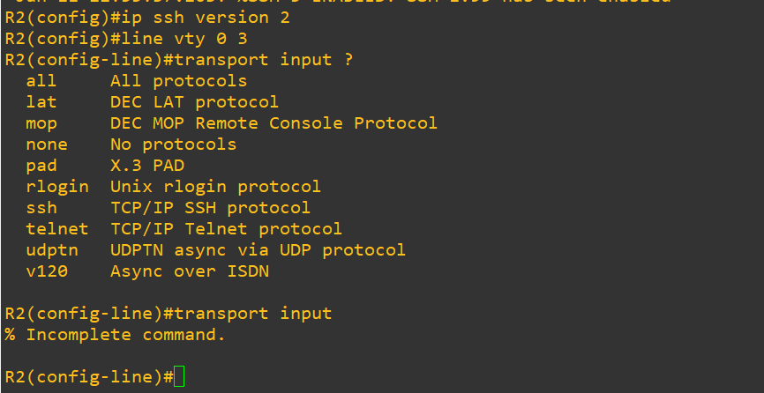

1. Set login password and then save configuration

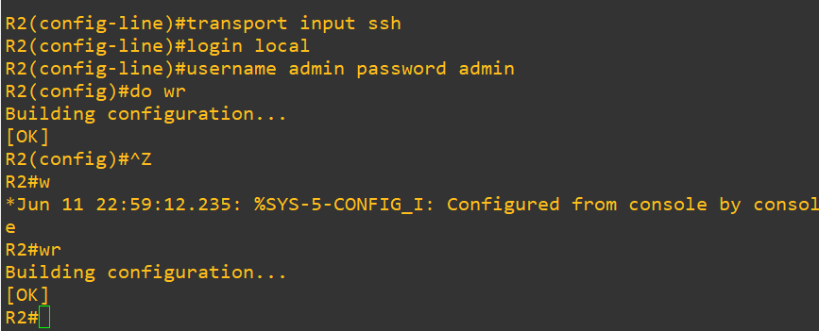

1. SSH into R2 from R1. Show run command shows all running configurations

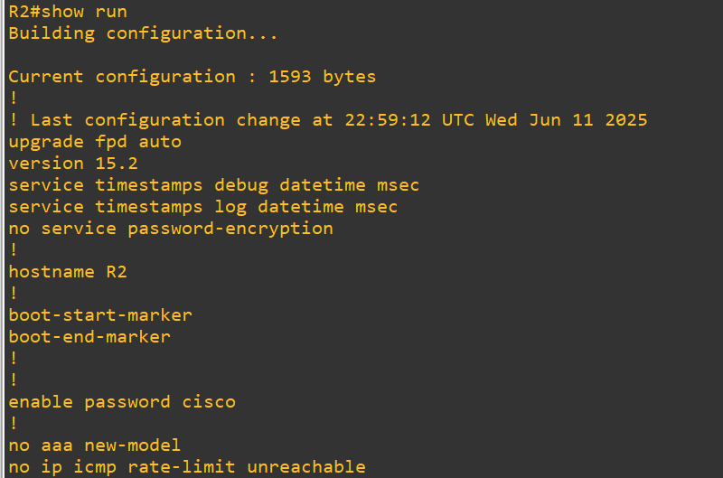

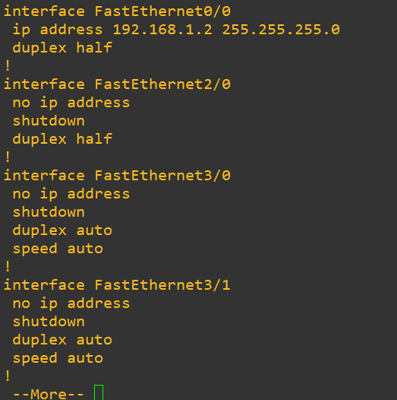

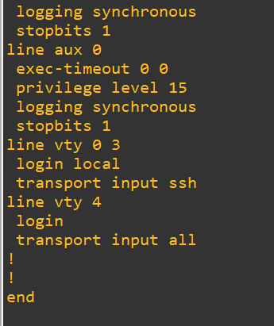

We configured SSH in router 2. Will access router 2 from router 1

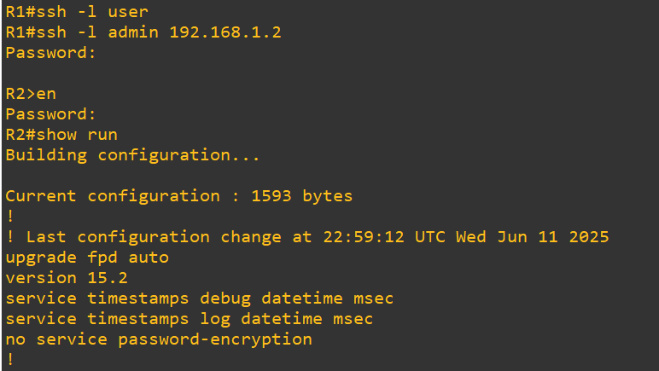

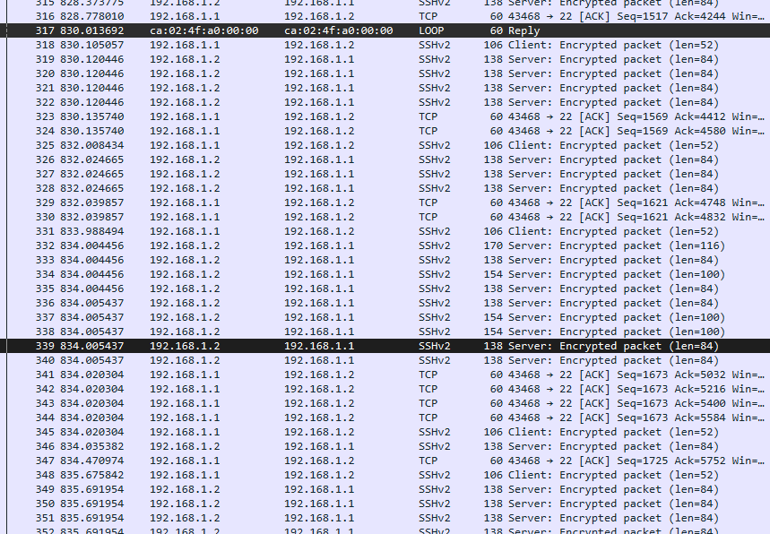

1. See the TCP stream for any randomly chosen packet; we can see that the data is encrypted in SSH unlike in Telnet

